

**First piloting report**

Deliverable 2.7.1

SmartZoos project

# Priit Tammets

# Terje Väljataga

# Pjotr Savitski

Kai-Mikael Jää-Aro

Tallinn University, School of Digital Technologies

Södertörn University

2017

# 1. Introduction

The main objective of the SmartZoos project is to integrate the Zoos of the Central Baltic region into a joint tourist attraction through developing a cross-border service package of creative adventure learning with mobile devices. The service package includes:

* an online tool for creating interactive assignments
* an online repository of interactive assignments
* an online environment (Web platform + mobile clients) for composing and conducting location-based adventure games, challenges and tournaments

The deliverable provides an overview of the first prototype of an online tool for creating interactive assignments and its first piloting results.

2. Overview of the SmartZoos online tool

2.1. Theoretical underpinnings

SmartZoos is following the principle that visitors will be able to enrich the experience of visiting the zoos with their mobile devices in two ways:

* to accept challenges and adventure trails created by other visitors;
* to allow visitors to design and create challenges and adventure trails for other visitors.

The latter one is supported from the pedagogical perspective by the ideas of knowledge building and trialogical learning. Trialogic learning emphasizes the central role of operations on, and through, knowledge objects. In this view it is essential that “learners as creators” collaboratively create and develop shared, novel (digital) artifacts with the support of (digital) instruments of various kinds [1]. Paavola and Hakkarainen [2] state that “in trialogues the central aim is not to enhance dialogues but the common ground is provided by jointly constructing external representations, practices and artifacts (dialogues can, of course, help here). Knowledge building and creation stresses the importance of idea (conceptual artifact) advancement, expansion and improvement; and the ability of learners to develop cultural or conceptual objects. In this manner, learners can construct their own knowledge by incorporating and elaborating on artifacts.

2.2. SmartZoos service package

The emerging notion of “students as creators” and related conceptual frameworks like “trialogical learning” and “knowledge building” will be the basis for developing and designing the SmartZoos service package.

The SmartZoos technical solution follows the idea of *Avastusrada* developed by the same research group. Avastusrada is a web-service for mobile devices to enable creation of interactive trails with mobile devices and designed mainly for nature centers and schools. SmartZoos was planned as an extension of Avastusrada for the SmartZoos project.

The SmartZoos technical solution is based on the PHP framework Laravel, Node.js and Gulp. The Google Maps API is used for the maps layer and the user interface is based on Bootstrap. The platform will make use of Mozilla Open Badges framework for recording the achievements of players.

The first prototype of an online tool (see Figures 1, 2, 3) is quiz-based: a set of questions (“activity”)—each multiple-choice, image-matching, or other type of puzzle (“activity item”)—appropriate to the game level of the player, is retrieved from the repository and presented on a map for the player to solve. The questions can be either randomly selected from the repository, or sorted as a trail with a specific purpose. Successfully answered quizzes gain points for the player. Higher-level players are invited to create new questions for other players to respond to.

The screenshots of the first prototype of the SmartZoos online tool:

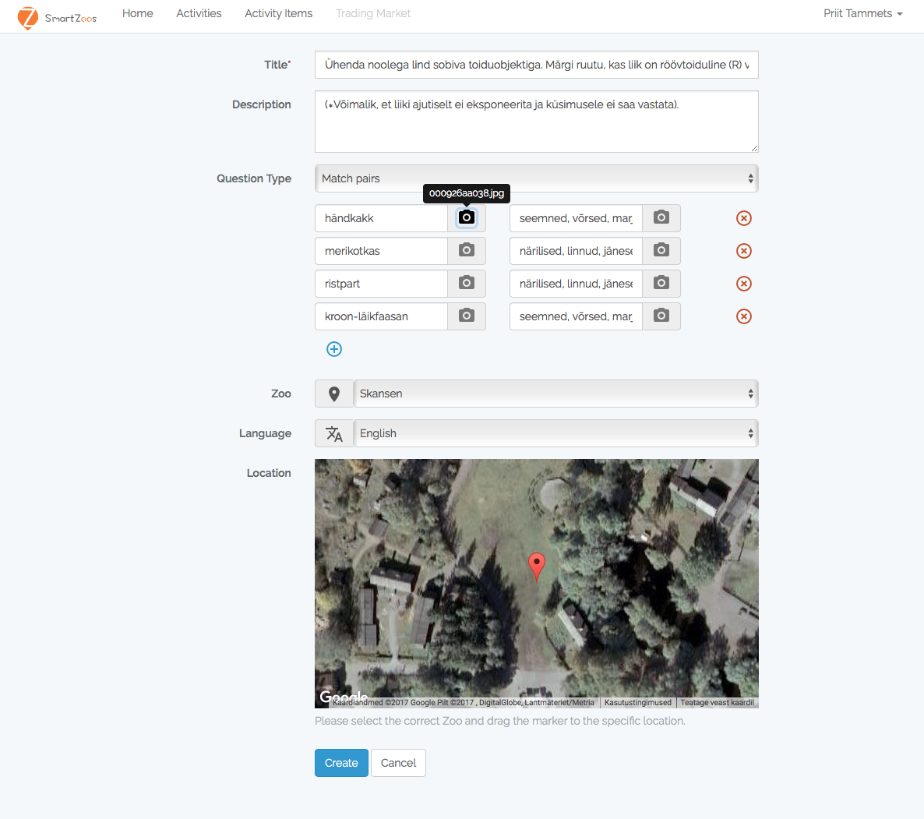

Figure 1. Screenshot of the SmartZoos tool: adding a photo for an activity item “match pairs”

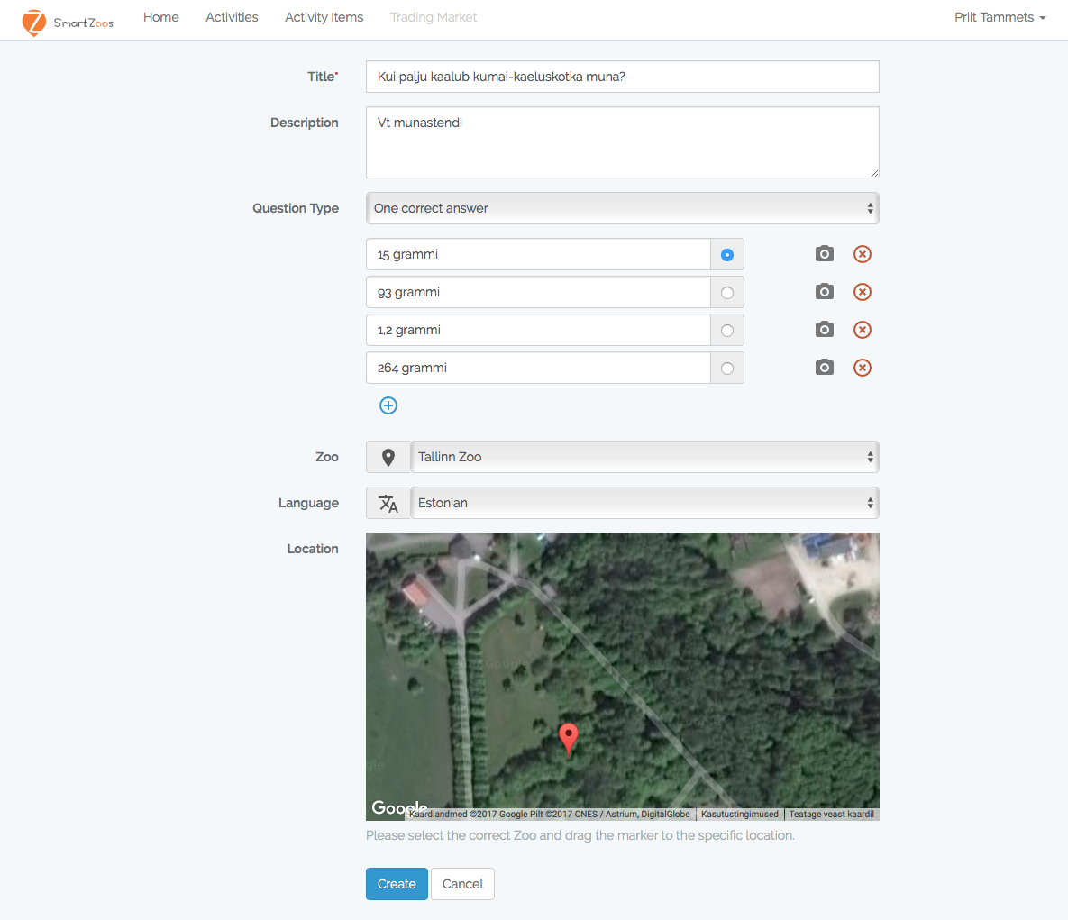

Figure 2. A screenshot of the SmartZoos tool: adding new activity item.

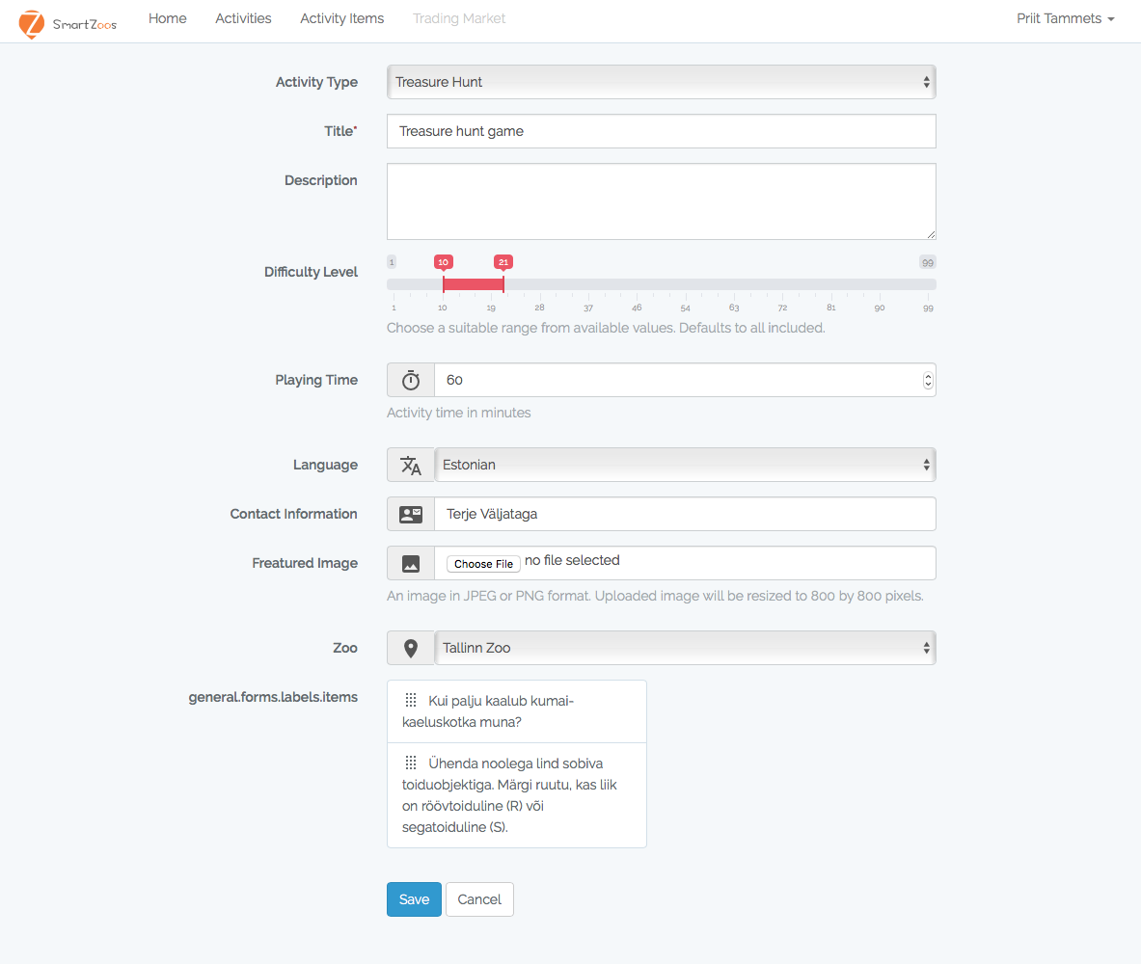

Figure 3. A screenshot of the SmartZoos tool: adding new activity.

The online tool for creating adventure trails can be found here: <https://toolset.smartzoos.eu/>

and its development progress can be followed here: <https://github.com/SmartZoos/Toolset>

2.3. SmartZoos potential scenarios and personas

Within the context of the SmartZoos project we aim at designing and developing creative and collaborative, game-based learning scenarios through social and digital artifact interactions using personal portable devices. These example scenarios will have the potential to engage visitors in active knowledge creation, designing and sharing knowledge objects during and after their visits to zoos. A potential exemplary scenario is described below.

*A. Scenario*

5th grade students visit a zoo in relation to their biology course. They are just passing the section on mammals and their teacher has planned their activities out of the classroom, in the zoo. The teacher has prepared the trail with the application. She has planned that following the trail should not exceed 45 minutes for passing and selecting points that guide the learners to visit all the mammals included. The activity has been planned as a group exercise—students team up in groups of 2–3 and use one device per team. At every study point (mammal enclosure), a learning activity is planned for students. Sometimes it is to test previous lessons, sometimes students have to take a photo of the animal. One of the questions is “What was the lunch of the tigers today?” and one group takes a photo of the tiger eagerly eating meat that a caretaker just served.

By submitting the answers, students have a chance to see what others answered—their photos and videos become part of their learning experience. The quiz questions feed back to the students that e.g. 95% of the other visitors also said that the tiger in the cage is a Bengal tiger, while 3% thinks it is a Siberian tiger and 2% a Sumatran tiger.

After the visit to the zoo, the teacher discusses the experience with the students in the picnic ground. They discuss what animals they met and what learning activities they performed together and their correct answers.

*B. Scenario*

Visitors to the zoo access the game page of the zoo web site. New quiz games are generated for them from the question database. The visitors then have to move through the zoo in order to reach the points where they can see and respond to the questions. As each game is randomly generated they are with a larger probability visiting parts they might not have been to earlier, thus the game should be more attractive as each play will be different. If all questions in a quiz are answered correctly a player can redeem a voucher for discounts or free entry at the same, or foreign zoo. As players “level up” the questions become more difficult and require cooperation with other players, potentially at other zoos. At the highest levels, the players gain permission to add new questions to the database.

To summarize, the features that further the project goals of a) increasing revisits to the zoo, b) increasing visits to foreign zoos, c) increasing public awareness of zoology and ecology, d) doing this in a sustainable manner are, respectively: a) The game has high replayability due to the generated quizzes being novel and interesting, as well as having multiple levels of challenges, in particular the attainment of the ability to create questions of one’s own that will be publicly visible [4]. b) Higher-level quizzes may require visiting multiple zoos in order to answer all questions, alternatively getting in contact with players at the other zoos in order to get them to find out answers to questions. The prizes given on the higher levels include free admission at foreign zoos. c) Well-designed questions require the players to move through the zoo and observe how the animals behave and may require the reading of background material, possibly from outside sources, in order to be replied to. d) As players level up and start crafting their own questions, they will fill out the database, making following games all the more interesting, while requiring less effort by the zoo staff.

3. Piloting of the SmartZoos tool

3.1. The preliminary heuristic evaluation of the SmartZoos tool

The overall design and development of the service package and its research follows a design-based research methodology. The initial design ideas of the SmartZoos service package were developed in participatory design sessions with experts from the technical, pedagogical and natural science fields. A heuristic evaluation of the first prototype of the SmartZoos tool for creating actitivies was carried out by four pedagogical and technical experts. This evaluation will be the basis to improve the overall design and usability of the tool. The goal of the heuristic evaluation was to identify usability issues, e.g. how easy and understandable it is for the user to navigate through the tool. In addition to the usability principles the congruence between the tool design and underpinning pedagogical framework was under focus. The following heuristics were considered important at this stage of the tool development:

* User control: the user feels control over the tool.
* Linguistic clarity: the language used is clear and suitable.
* Aesthetic integrity: the design of the tool is visually attractive and tailored to appeal to the users.
* Simplicity: the design is simple and does not use unnecessary complexity.
* Predictability: the user will be able to form a mental model of how the tool will behave in response to actions.
* Accuracy: the result of user actions corresponds to their goals.
* Fulfillment: the user experience is adequate and the user feels good about the experience.
* Consistency: different parts of the tool have the same style, so that there are no different ways to represent the same information or behavior.
* User support: the design will support learning and provide the required assistance to usage.
* Precision: the steps and results of a task will be what the user wants.
* Forgiveness: the user will be able to recover to an adequate state after an error.
* Responsiveness: the interface provides the user enough feedback information about the service package status and their task completion.

The following set of user tasks were defined for the experts to accomplish with the SmartZoos tool:

* Create an account
* Log into the system
* Create 3 activity items and turn them into a simple game.

The experts made use of the tool with their own pace and answered the questions related to the defined heuristics. Whenever it was necessary, additional comments and suggestions were provided.

**Results**

The overall impression of the tool was rather positive and provided exciting experiences for the users. Being visually attractive and a considerably simple tool, the tool also offered the user certain control over it. Despite of the experts’ positive experiences, however, they encountered some challenges, which should be addressed in the next developmental phase of the tool. For instance, users need clearer instructions of how to create a game or an adventure trail. It turned out that the linguistic clarity needs further attention as the experts claimed the use of vocabulary in the tool is not very intuitive to grasp. Currently an *activity item* in the tool refers to an assignment type (a multiple choice test, free answer, etc.) and a set of created items will be formed into a game—an *activity*, which in turn has different types a user can choose from (Figure 3).

Another challenge to look at in the next developmental round is related to the predictability heuristic. The experts reported that the tool doesn’t invite them to form a clear mental model of how the tool will behave in response to their actions. As the tool development is still work in progress the experts also detected a number of simple technical bugs, e.g. saving created trails. Furthermore, for the user it is not so intuitive to recover to an adequate state after an error. 3 out of 4 experts experienced that the interface of the tool lacks responsiveness. For example, the status of the user while navigating through the tool was not self-explanatory.

3.2. User experience with the SmartZoos tool

First pilot study with the potential users was carried out in Tallinn Zoo. The goal of the pilot study was to get preliminary feedback from the potential users in terms of user interface design and the general user experience with the tool. The users had an option to go through the tool with their own pace and time. They were asked to create some activity items (assignments) with specific locations and put them together as an activity (trail).

The overall user experience was positive, however, rather similar aspects were pointed out as the heuristic evaluation. A list of useful issues was given by the users to be considered for the next developmental round.

* the overall design of the tool can be more attractive. Some of the users didn’t find the tool very intuitive. A kind of help or tutorial might be needed in order to grasp the workflow of the tool.
* vocabulary used in the tool. Currently the tool can be used in English. In the beginning some of the users found the use of terms in the tool a bit confusing as it was not very clear immediately what an *activity item* and an *activity* actually referred to. In addition, the term *Description* was not unequivocally understandable for all the test users.
* displaying difficulty level. Currently there is an option to choose difficulty level of the activity according to an age. Some of the users suggested to attach the difficulty level rather to an activity item. Furthermore, instead of using age, the difficulty level could be divided according to the school levels.
* searching for activity items for designing a game. The title of an activity item plays an important role for finding the right activity items for one’s game. Some of the users also recommended a search option of activity items according to keywords.
* map of the zoo. Some of the users suggested having a map of the zoo while playing a game. That would help the user to get an overview of the area he or she is supposed to go through.
* distance between the markers of the game. The distance between the markers could be displayed for the user in order to get an overview of how far each marker is from the next one.

To conclude, the preliminary heuristic evaluation of the SmartZoos tool carried out by the experts and the first pilot study provided some useful hints and tips to consider for the next developmental phase.

References

[1] S. Paavola, R. Engestrom, & K. Hakkarainen, “Trialogical approach as a new form mediation,” in *Collaborative Knowledge Creation: Practices, Tools, Concepts*, A. Moen, A.I. Morch, S. Paavola, Eds. 2012, pp. 1–14.

[2] S. Paavola, & K. Hakkarainen, “From meaning making to joint construction of knowledge practices and artefacts—a trialogical approach to CSCL”, *Proc. of the 9th International Conference on Computer Supported Collaborative Learning*, 1, 2009, pp. 83–92.

[3] O’Hara, T. Kindberg, M. Glancy, L. Baptista, B. Sukumaran, G. Kahana & J. Rowbotham, “Collecting and sharing location-based content on mobile phones in a zoo visitor experience”. *Computer Supported Cooperative Work (CSCW)*, vol. 16(1–2), pp.11–44, 2007.

[4] L. Grant, H. Daanen, S. Benford, A. Hampshire, A. Drozd & C. Greenhalgh, “MobiMissions”. *ACM SIGGRAPH 2007 Educators Program*, 2007.